Kubernetes Task -02

TASK TITLE
Kubernetes Pod Management Using YAML and kubectl
OBJECTIVE
To gain hands-on experience in creating, configuring, and managing Kubernetes Pods using YAML manifests and kubectl commands. This includes working with environment variables, container arguments, multi-container Pods, init containers, dry-run YAML generation, deployment strategies, Pod editing, Services, and resource management.

PREREQUISITES
• Basic understanding of Kubernetes architecture
• Kubernetes cluster configured (Minikube / kubeadm / managed cluster)
• kubectl installed and configured
• At least one worker node available
• Familiarity with YAML syntax
• Container runtime available (Docker / containerd)
• Network connectivity between cluster components

CONCLUSION
Successfully performed Kubernetes Pod operations using YAML and kubectl. Demonstrated the ability to configure Pods with environment variables, container arguments, multiple containers, init containers, and resource constraints. Validated Pod behavior through describe, logs, exec, and Service exposure. Gained practical understanding of kubectl create vs apply workflows and live Pod modifications, reinforcing core Kubernetes management concepts essential for real-world deployments and DevOps practices.

1.Create a Simple Pod Using YAML Task: Write a YAML file to create a Pod named firstpod with an nginx container. Verify the Pod creation using kubectl get pods and check the logs of the container using kubectl logs firstpod.
STEPS PERFORMED
Opened a new YAML file
• vi firstpod.yaml
Added the Pod configuration
• apiVersion: v1
• kind: Pod
• metadata:
name: firstpod
• spec:
containers:
- name: nginx-container
image: nginx
ports:
- containerPort: 80
Saved and exited the YAML file
Applied the YAML file to create the Pod
• kubectl apply -f firstpod.yaml
Verified that the Pod was created and running
• kubectl get pods
Checked the logs of the Pod
• kubectl logs firstpod
Observed nginx startup logs confirming successful container execution

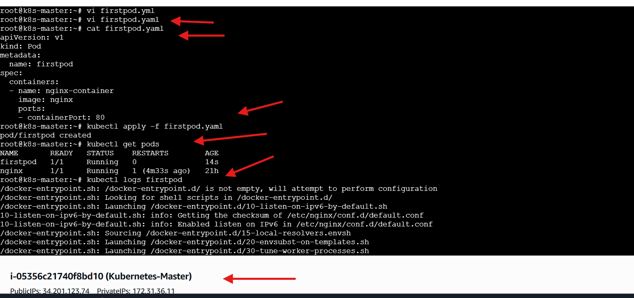

2.Set Environment Variables in a Pod Task: Modify the YAML file to include environment variables myname: sabair and City: Hyderabad. Deploy the Pod and use kubectl exec <pod_name> -- env to check if the environment variables are set properly.
STEPS PERFORMED
Opened a new YAML file
• vi firstpod-env.yaml
Added the Pod configuration with environment variables
• apiVersion: v1
• kind: Pod
• metadata:
name: firstpod-env
• spec:
containers:
- name: nginx-container
image: nginx
env:
- name: myname
value: "sabair"
- name: City
value: "Hyderabad"
Saved and exited the YAML file
Attempted to apply the YAML file
• kubectl apply firstpod-env.yaml
Observed error due to incorrect syntax
• Error: Unexpected args
Applied the YAML file using correct syntax
• kubectl apply -f firstpod-env.yaml
Verified that the Pod was created and running
• kubectl get pods
Executed command inside the Pod to verify environment variables
• kubectl exec firstpod-env -- env
Observed environment variables inside the container
• myname=sabair
• City=Hyderabad
Confirmed successful Pod execution with environment configuration
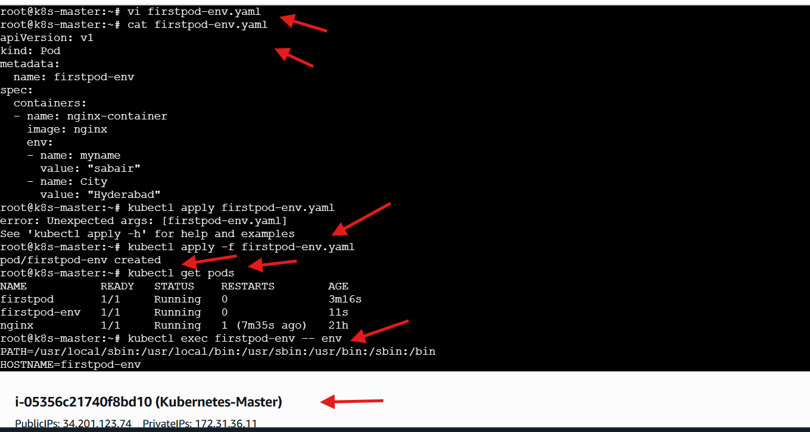
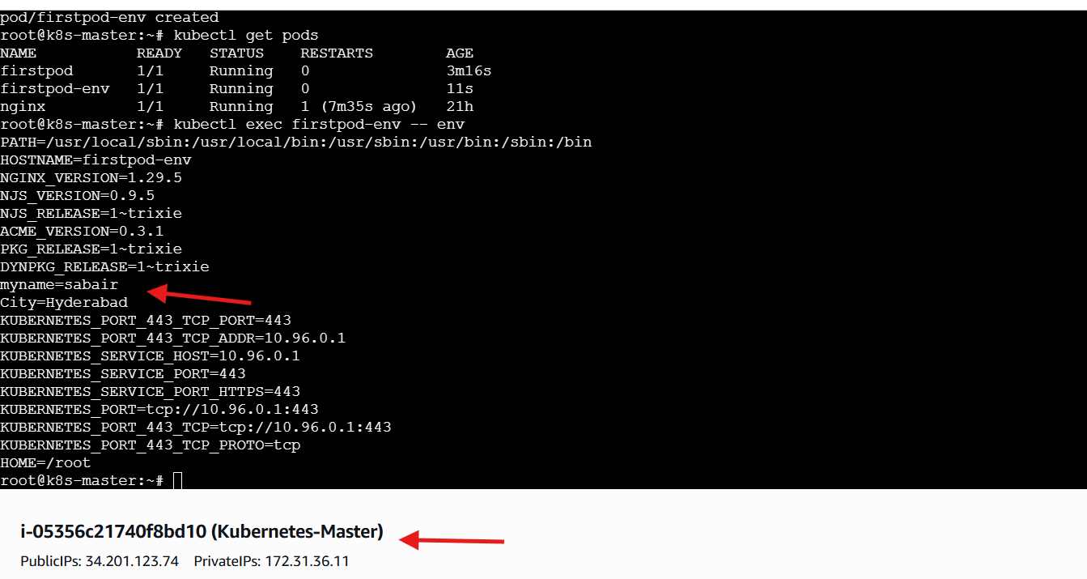

3.Deploy a Pod with Commands (Args) in YAML Task: Modify the YAML file to add args that instruct the container to sleep for 50 seconds. Deploy the Pod and use kubectl describe pod to verify the args are correctly passed to the container.
STEPS PERFORMED
Opened a new YAML file
• vi firstpod-args.yaml
Added the Pod configuration with container arguments
• apiVersion: v1
• kind: Pod
• metadata:
name: sleep-pod
• spec:
containers:
- name: nginx-container
image: busybox
args: ["sleep", "50"]
Saved and exited the YAML file
Applied the YAML file to create the Pod
• kubectl apply -f firstpod-args.yaml
Verified that the Pod was created and running
• kubectl get pods
Described the Pod to inspect container details
• kubectl describe pod sleep-pod
Observed Pod scheduling and container lifecycle events
• Successfully assigned Pod to worker node
• Pulled busybox container image
• Created container
• Started container
Confirmed successful Pod execution with container arguments
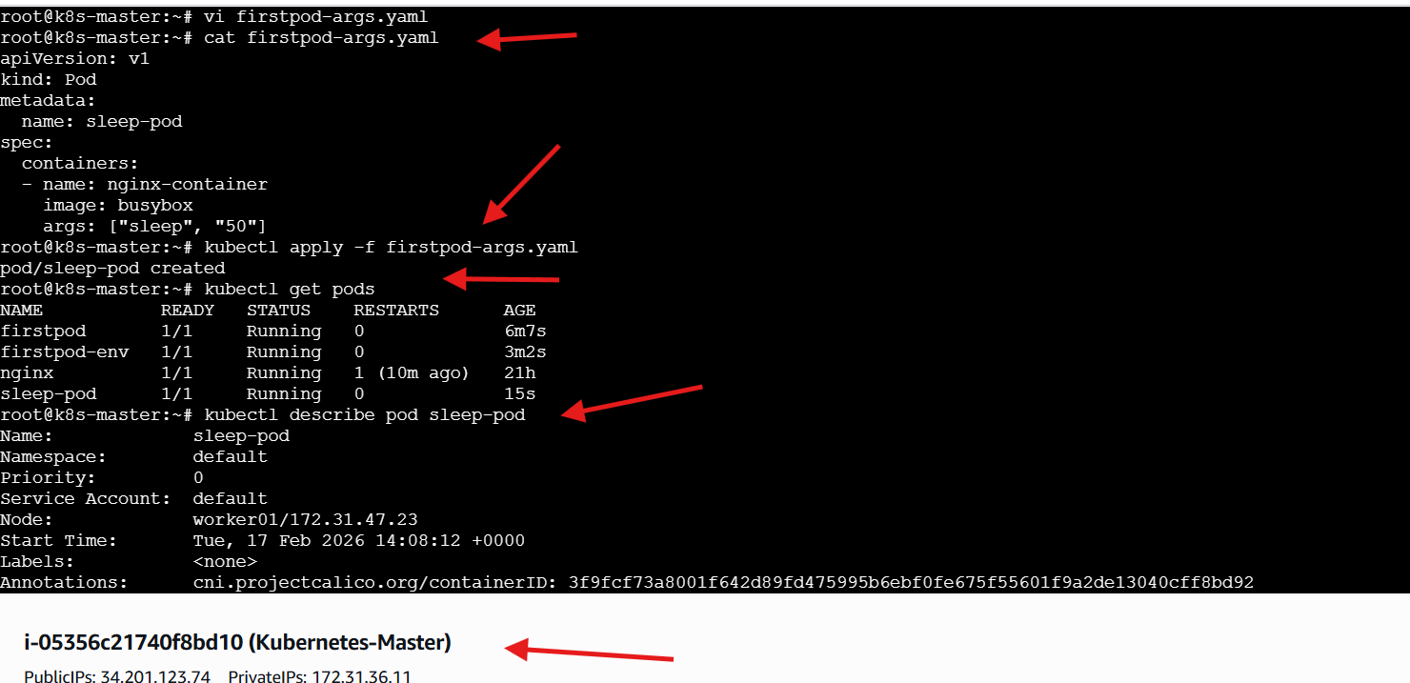
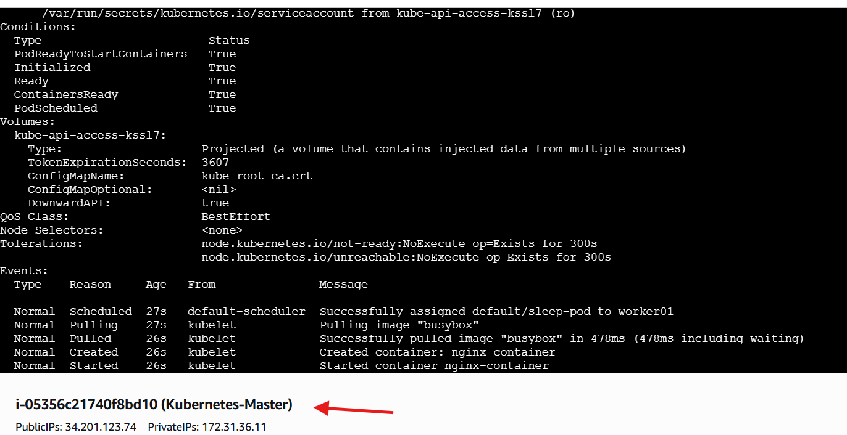
4.Create a Pod with Two Containers Task: Create a YAML file to define a Pod with two nginx containers inside. Use kubectl exec to access both containers and verify that both containers can communicate through the same network (e.g., using telnet between them).
STEPS PERFORMED
Opened a new YAML file
• vi twocontainer-pod.yaml
Added the Pod configuration with multiple containers
• apiVersion: v1
• kind: Pod
• metadata:
name: two-nginx-pod-fixed
• spec:
containers:
- name: nginx-1
image: nginx
ports:
- containerPort: 80
- name: nginx-2
image: nginx
command: ["/bin/sh"]
args:
- -c
- sed -i 's/listen 80;/listen 81;/' /etc/nginx/conf.d/default.conf && nginx -g 'daemon off;'
ports:
- containerPort: 81
Saved and exited the YAML file
Applied the YAML file to create the Pod
• kubectl apply -f twocontainer-pod.yaml
Verified that the Pod was created and running
• kubectl get pods
Accessed the Pod container for validation
• kubectl exec -it two-nginx-pod-fixed -c nginx-1 -- /bin/bash
Tested the second container’s nginx service
• curl localhost:81
Observed nginx welcome page confirming successful execution
Confirmed successful multi-container Pod deployment
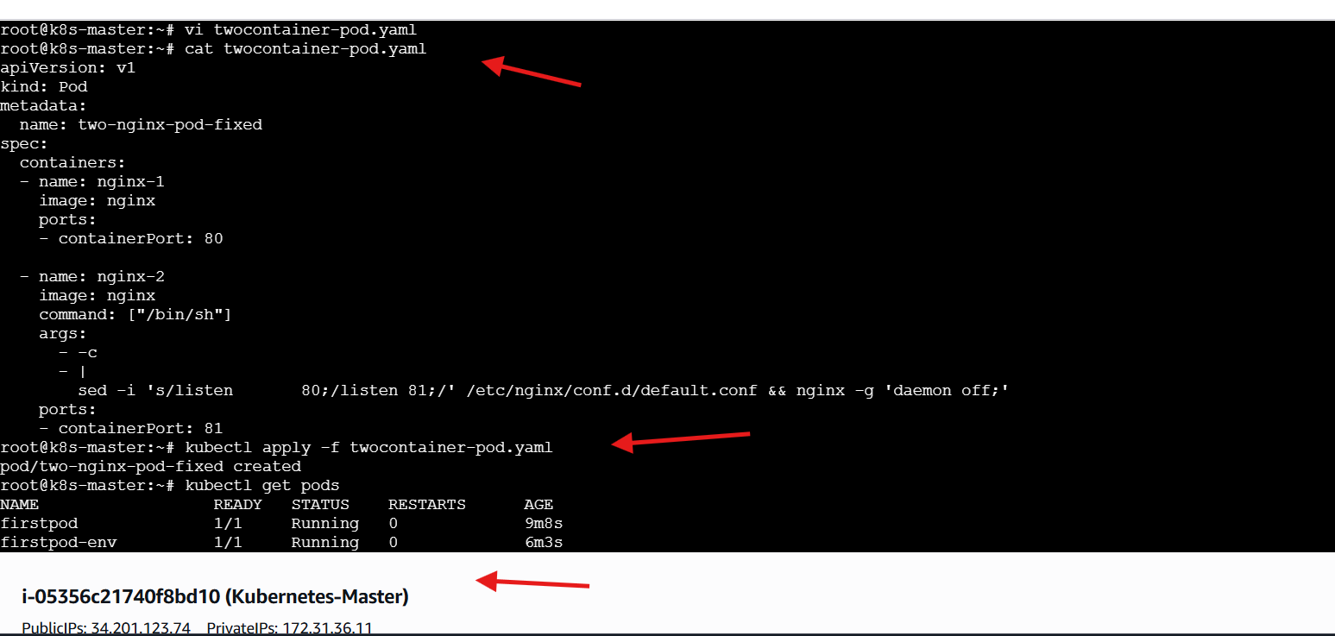
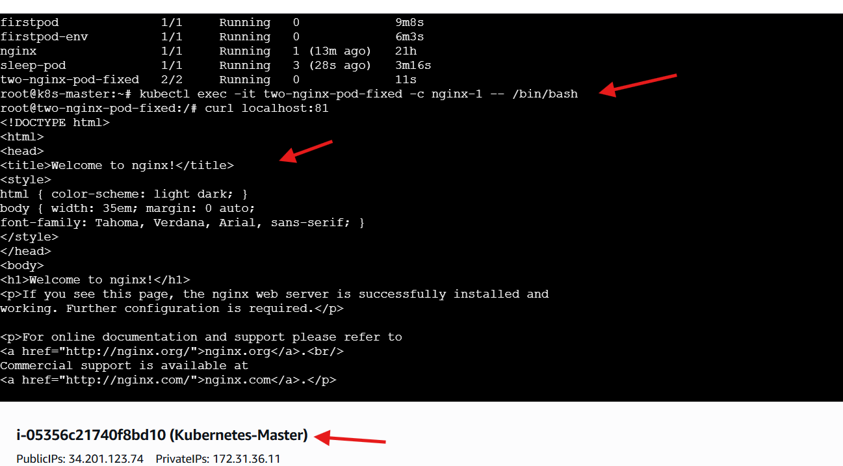

5.Set Up an Init Container in a Pod Task: Modify the YAML to include an init container that sleeps for 30 seconds before the main containers start. Verify the init container's execution using kubectl describe pod and check the logs to confirm its completion.
STEPS PERFORMED
Opened a new YAML file
• vi initpod.yaml
Added the Pod configuration with an Init Container
• apiVersion: v1
• kind: Pod
• metadata:
name: init-pod
• spec:
initContainers:
- name: init-container
image: busybox
command: ["sh", "-c", "sleep 30"]
containers:
- name: nginx-container
image: nginx
Saved and exited the YAML file
Applied the YAML file to create the Pod
• kubectl apply -f initpod.yaml
Verified Pod status
• kubectl get pods
Observed Pod initialization phase
• Pod entered Init state while init container executed
Described the Pod for detailed inspection
• kubectl describe pod init-pod
Observed Init Container execution flow
• Successfully assigned Pod to worker node
• Pulled busybox image
• Created init container
• Started init container
• Init container completed successfully
Observed Main Container execution
• Pulled nginx image
• Created nginx container
• Started nginx container
Confirmed successful Init Container lifecycle and Pod execution
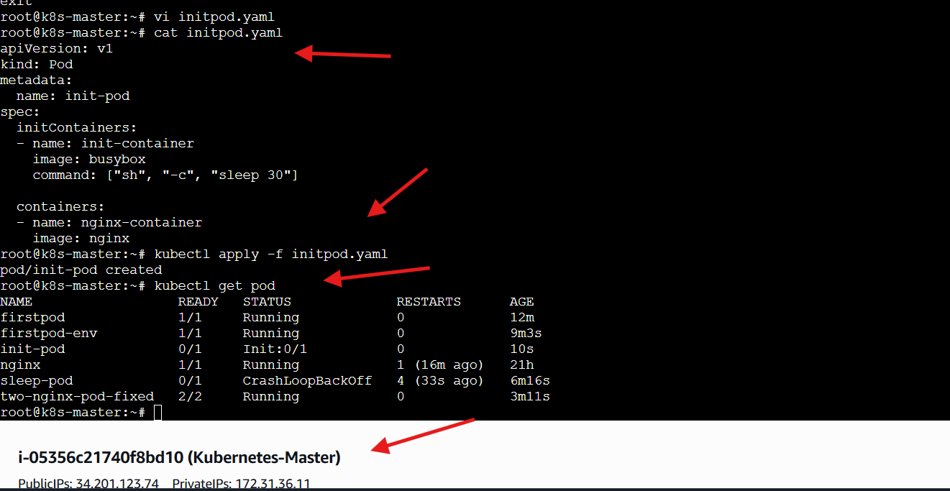
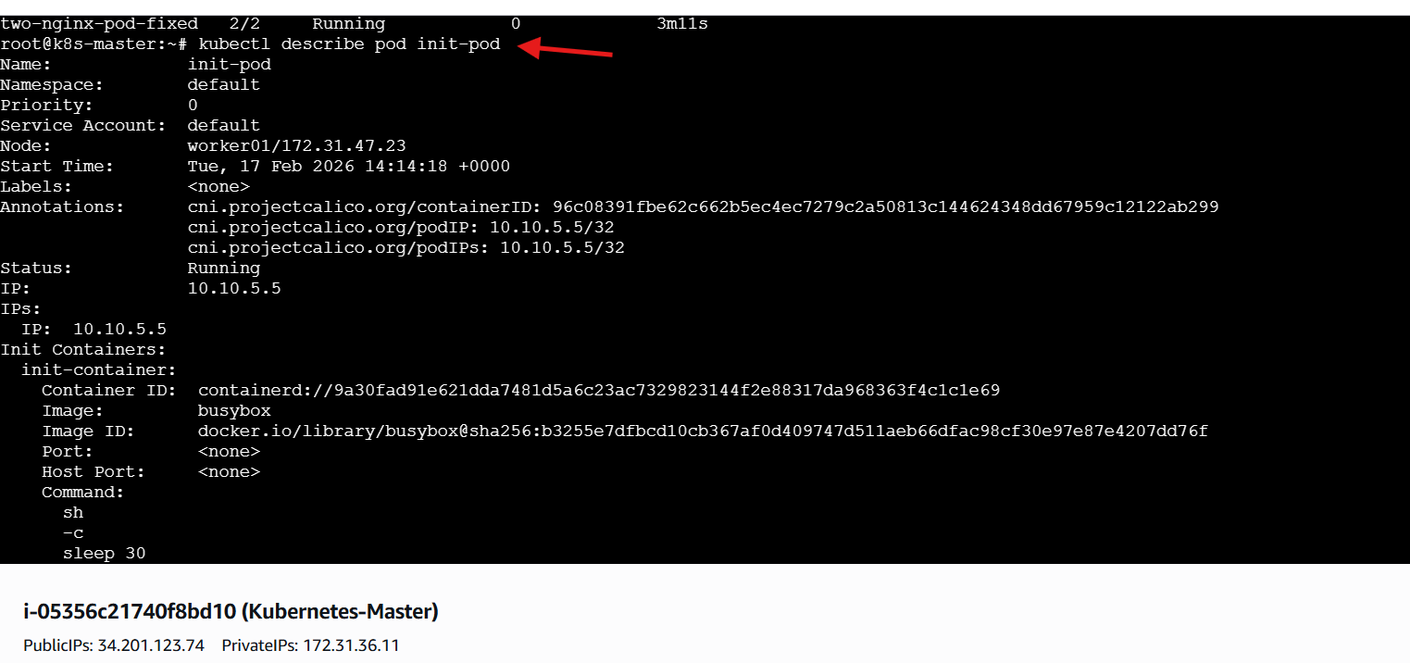
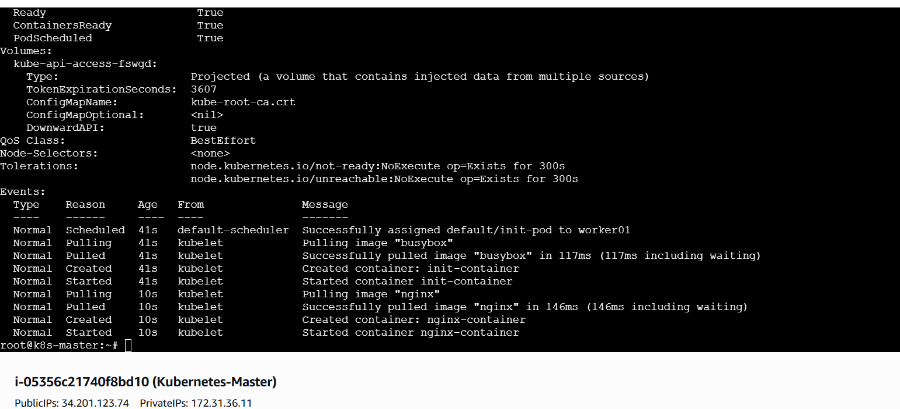
6.Run a Dry Run Command to Generate YAML Task: Use the kubectl run nginx --image=nginx --dry-run=client -o yaml command to generate a Pod YAML definition. Modify the generated YAML to suit specific requirements (e.g., labels or environment variables) and deploy it.
STEPS PERFORMED
Generated a Pod YAML using dry-run
• kubectl run nginx --image=nginx --dry-run=client -o yaml > nginx.yaml
Viewed the generated YAML file
• cat nginx.yaml
Edited the YAML file
• vi nginx.yaml
Modified the Pod configuration
• apiVersion: v1
• kind: Pod
• metadata:
name: nginx
labels:
app: web
• spec:
containers:
- name: nginx
image: nginx:1.25
ports:
- containerPort: 80
env:
- name: ENV
value: "production"
Saved and exited the YAML file
Verified Pod status
• kubectl get pods
Described the Pod for detailed inspection
• kubectl describe pod nginx
Observed Pod details
• Pod successfully scheduled on worker node
• Container image pulled successfully
• Container created and started
• Pod assigned an internal cluster IP
Observed container lifecycle events
• Image pulled
• Container created
• Container started
Confirmed successful Pod deployment using dry-run generated YAML
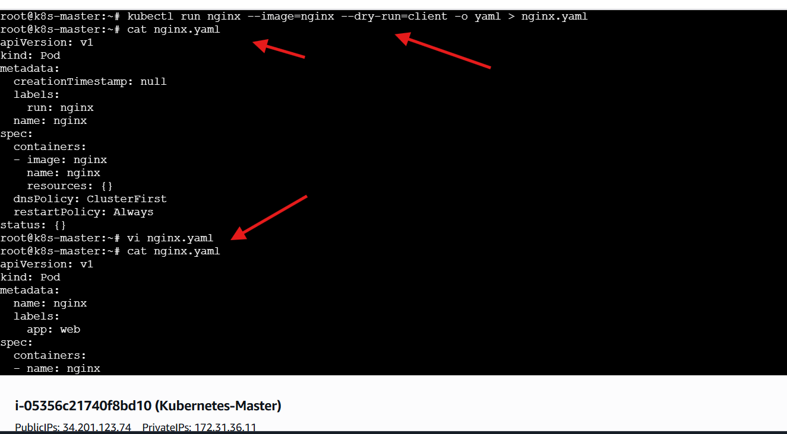
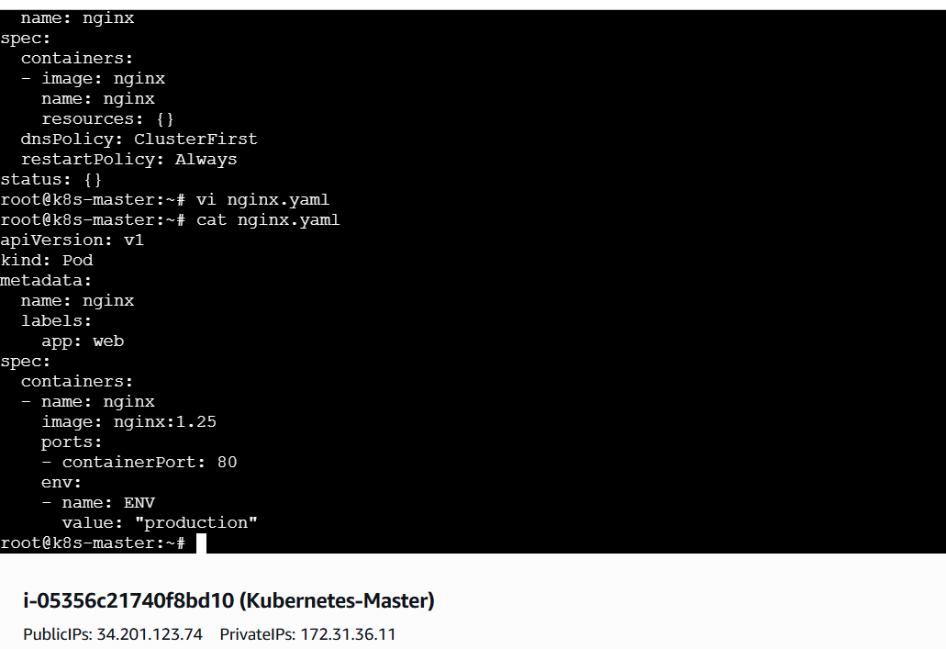
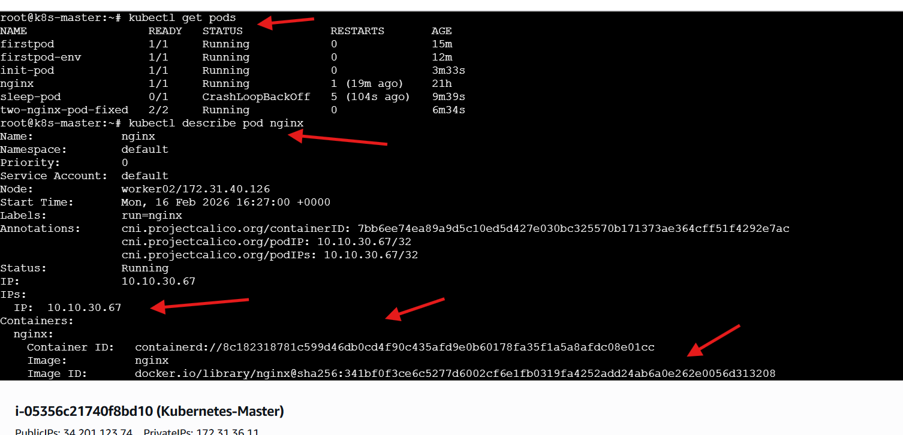
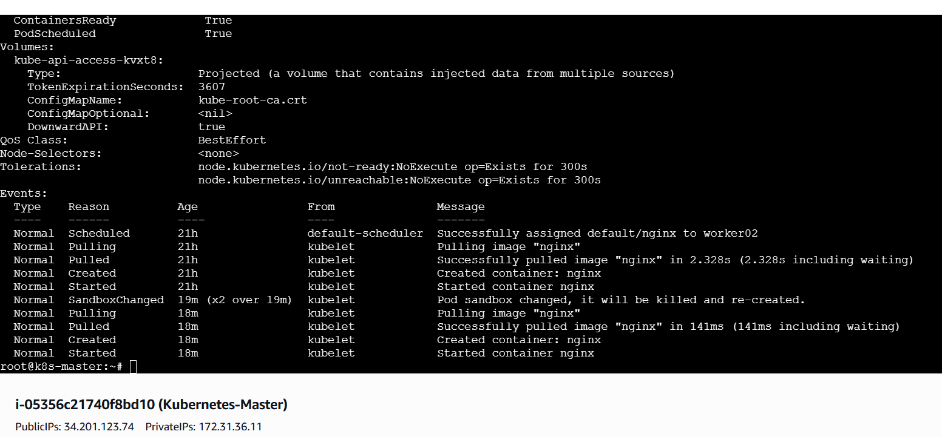

7.Use kubectl apply vs kubectl create Task: Create a YAML file to define a Pod. First, deploy it using kubectl create -f <file_name>.yml and then modify the YAML (e.g., change the image version). Use kubectl apply to redeploy and verify the difference between both commands.
STEPS PERFORMED
Attempted to create the Pod using YAML
• kubectl create -f firstpod.yaml
Observed error during creation
• Error: Pod already exists
Opened the existing YAML file for modification
• vi firstpod.yaml
Updated the container image version
• image: nginx:1.25
Saved and exited the YAML file
Applied the updated configuration
• kubectl apply -f firstpod.yaml
Observed configuration update
• Pod configured successfully
Verified Pod status
• kubectl get pods
Confirmed successful Pod update using kubectl apply
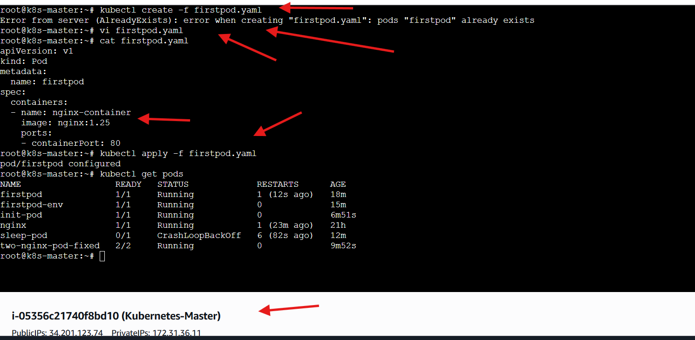

8.Edit an Existing Pod Configuration Task: Use kubectl edit pod <pod_name> to modify the running Pod's environment variables or image. After making the changes, verify if they took effect by checking the container logs or environment variables using kubectl exec.
STEPS PERFORMED
Edited the running Pod
• kubectl edit pod firstpod
Modified Pod configuration
• Updated container image settings
Saved and exited the editor
Observed successful update
• Pod firstpod edited
Described the Pod for verification
• kubectl describe pod firstpod
Observed updated Pod details
• Pod running successfully
• Container image updated
• Container restarted automatically
Verified container runtime events
• Image pulled successfully
• Container created
• Container started
Executed command inside the Pod
• kubectl exec firstpod -- env
Observed container environment details
Confirmed successful live Pod modification
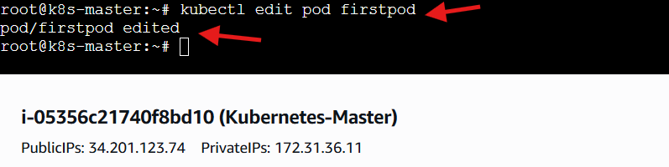
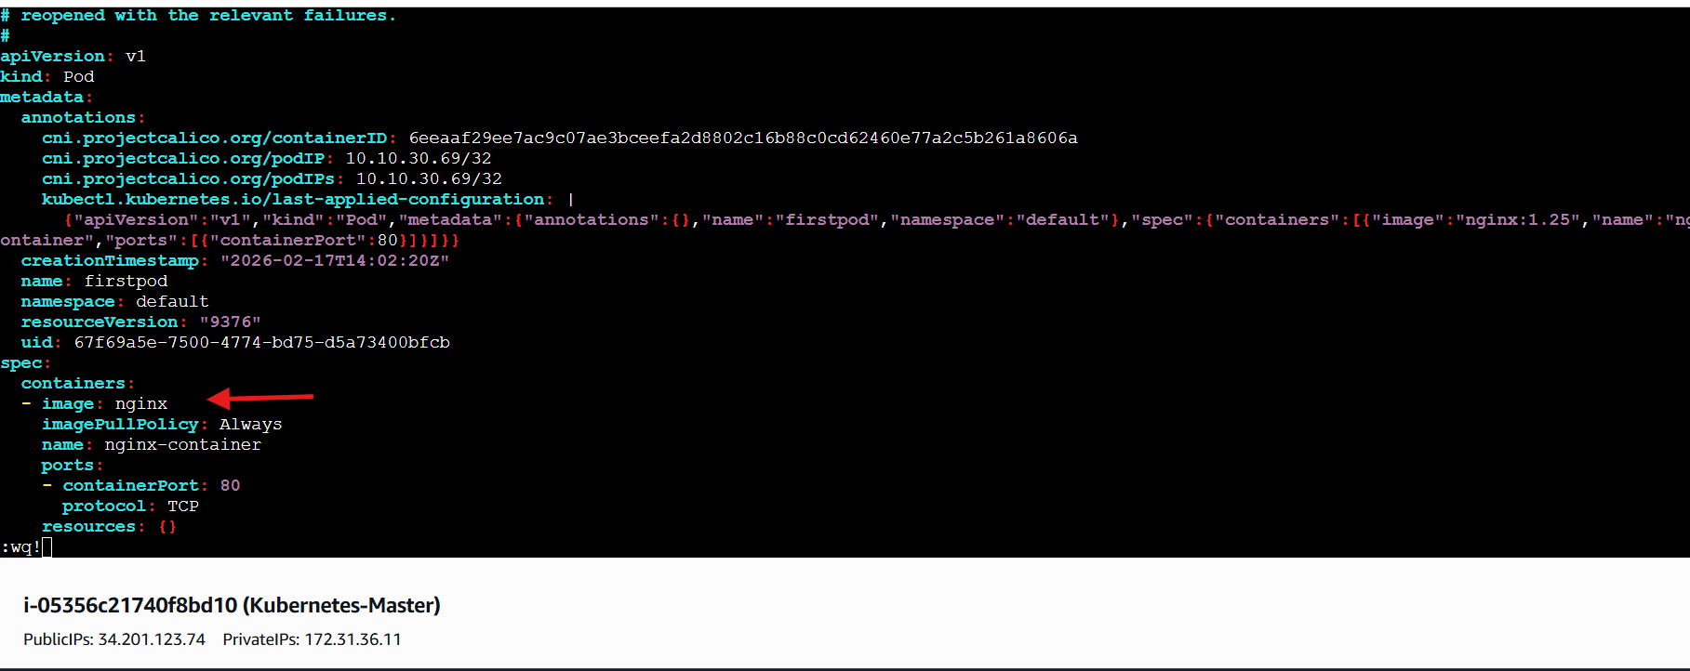
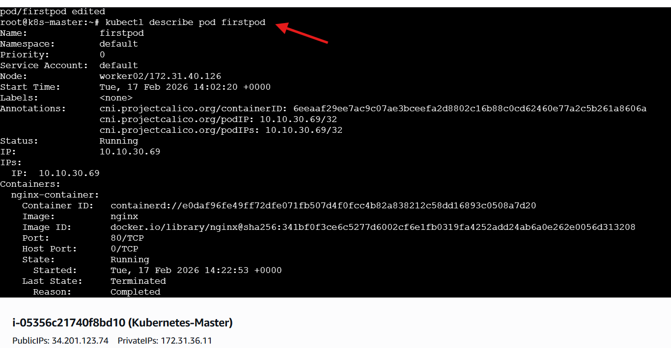
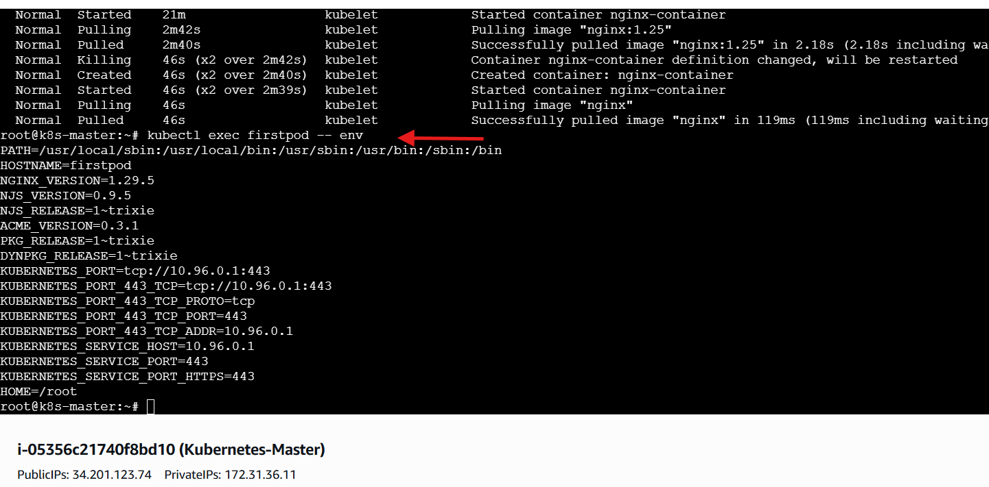

9.Expose a Pod Using a Service Task: Create a YAML file to expose your firstpod using a Service (ClusterIP). Ensure that your service is exposing the Pod on port 80 and verify it using kubectl get svc.
STEPS PERFORMED
Opened a new YAML file
• vi service.yaml
Added the Service configuration
• apiVersion: v1
• kind: Service
• metadata:
name: firstpod-service
• spec:
type: ClusterIP
selector:
app: web
ports:
- port: 80
targetPort: 80
Saved and exited the YAML file
Applied the Service configuration
• kubectl apply -f service.yaml
Observed successful Service creation
• Service firstpod-service created
Verified Service details
• kubectl get svc
Observed Service information
• ClusterIP assigned
• Port mapping configured
Confirmed successful Service deployment
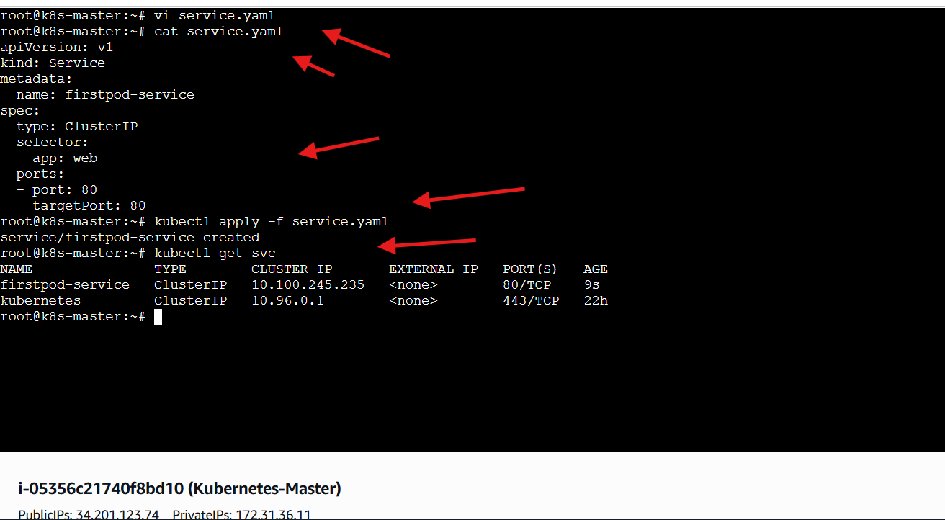

10.Pod with Resource Limits and Requests Task: Add resource requests and limits to the containers in your YAML file. Specify CPU and memory requests/limits for both containers and deploy the Pod. Use kubectl describe pod to verify if the resource configurations are correctly applied.
STEPS PERFORMED
Opened a new YAML file
• vi resource-pod.yaml
Added the Pod configuration with resource requests and limits
• apiVersion: v1
• kind: Pod
• metadata:
name: resource-pod
• spec:
containers:
- name: nginx-1
image: nginx
resources:
requests:
memory: "64Mi"
cpu: "250m"
limits:
memory: "128Mi"
cpu: "500m"
- name: nginx-2
image: nginx
resources:
requests:
memory: "64Mi"
cpu: "200m"
limits:
memory: "128Mi"
cpu: "400m"
Saved and exited the YAML file
Applied the YAML configuration
• kubectl apply -f resource-pod.yaml
Observed successful Pod creation
• Pod resource-pod created
Described the Pod for verification
• kubectl describe pod resource-pod
Observed resource allocation details
• CPU requests configured
• Memory requests configured
• CPU limits configured
• Memory limits configured
Confirmed successful Pod deployment with resource constraints
